Interface Studio Test Plan

CVP 2022.1.0

Interface Configuration Studio ver. 1.15

Inputs files used are in Studios/Interface Configuration directory

## Tested Hardware – SE Lab:

7280R3 – dc3-leaf1 EOS 4.27.0F

720XP – dc3-leaf2, dc3-leaf3, dc3-leaf4 EOS 4.27.2F

7050X3 – dc3-spine1, dc3-spine2 EOS 4.27.0F

# General Profile Features on Ports:

1. Access Port features
   1. Tested below features on Old Interface UI

7280R3 – dc3-leaf1

ethernet 3 – non PC

720XP – dc3-leaf2

ethernet 6 - PC

* 1. Tested below features on Stack UI no Port Channel Ports

7280R3 – dc3-leaf1

ethernet 4-8

ethernet 51/1 – 52/1

720XP – dc3-leaf2, dc3-leaf3, dc3-leaf4

ethernet 7 -8

7050X3 – dc3-spine1, dc3-spine2

ethernet 7/1-8/1

1. Tested below features on Stack UI on Port Channel Ports

7280R3 – dc3-leaf1

ethernet 9-10

720XP – dc3-leaf2, dc3-leaf3, dc3-leaf4

ethernet 9-10

7050X3 – dc3-spine1, dc3-spine2

ethernet 9/1-10/1

* + 1. Port fast and BPDU Guard
    2. VLAN ID in profile
    3. VLAN ID not in profile
    4. Speed
    5. Command line field input
    6. Enable disable
  1. LACP (tested on PCs only)
  2. MLAG (tested on PC only)
  3. VLAN ID in profile
  4. VLAN ID not in profile

1. Routed Port features
   1. Tested below features on Old Interface UI non Port Channel whole port

7050X3 – dc3-spine1

ethernet 5/1

* 1. Tested below features on Stack UI no Port Channel whole port

7280R3 – dc3-leaf1

ethernet 11 routed w IP in profile

ethernet 12 routed w IP in interface config

ethernet 13 routed w IP in interface config in VRF

720XP – dc3-leaf2, dc3-leaf3, dc3-leaf4

ethernet 11 routed w IP in profile

ethernet 12 routed w IP in interface config

ethernet 13 routed w IP in interface config in VRF

7050X3 – dc3-spine1, dc3-spine2

ethernet 11/1 routed w IP in profile

ethernet 12/1 routed w IP in interface config

ethernet 13/1 routed w IP in interface config in VRF

1. Tested below features on Old Interface UI Routed Subinterfaces

7050X3 – dc3-spine2

ethernet 5/1

1. Tested below features on Stack UI Routed Subinterfaces

7280R3 – dc3-leaf1

ethernet 14.301 routed w IP in profile

ethernet 14.302 routed w IP in interface config

ethernet 15.302 routed w IP in interface config in VRF

ethernet 53/1.501 routed w IP in profile

ethernet 53/1.502 routed w IP in interface config

ethernet 53/1.503 routed w IP in interface config in VRF

720XP – dc3-leaf2, dc3-leaf3, dc3-leaf4

ethernet 14.401 routed w IP in profile

ethernet 14.401 routed w IP in interface config

ethernet 14.403 routed w IP in interface config in VRF

7050X3 – dc3-spine1, dc3-spine2

ethernet 14/1.304 routed w IP in profile

ethernet 14/1.305 routed w IP in interface config

ethernet 14/1.306 routed w IP in interface config in VRF

1. Tested below features on Old Interface UI Routed Port Channel Whole Port

7050X3 – dc3-spine1

ethernet 6/1 – Port Channel subinterfaces

1. Tested below features on Stack UI Routed Port Channel Whole Port

7280R3 – dc3-leaf1

ethernet 16 routed w IP in profile

ethernet 17 routed w IP in interface config

ethernet 18 routed w IP in interface config in VRF

720XP – dc3-leaf2, dc3-leaf3, dc3-leaf4

ethernet 16 routed w IP in profile

ethernet 17 routed w IP in interface config

ethernet 18 routed w IP in interface config in VRF

7050X3 – dc3-spine1, dc3-spine2

ethernet 15/1 routed w IP in profile

ethernet 16/1 routed w IP in interface config

ethernet 17/1 routed w IP in interface config in VRF

1. Tested below features on Routed Port Channel Subinterfaces

7280R3 – dc3-leaf1

ethernet 19.701 routed w IP in profile

ethernet 19.702 routed w IP in interface config

ethernet 19.703 routed w IP in interface config in VRF

720XP – dc3-leaf2, dc3-leaf3, dc3-leaf4

ethernet 19.701 routed w IP in profile

ethernet 19.702 routed w IP in interface config

ethernet 19.703 routed w IP in interface config in VRF

7050X3 – dc3-spine1, dc3-spine2

ethernet 18/1.701 routed w IP in profile

ethernet 18/1.702 routed w IP in interface config

ethernet 18/1.703 routed w IP in interface config in VRF

* + 1. IP address in profile
    2. IP address not in profile
    3. Speed
    4. LACP
    5. RPF
    6. VRF
    7. DHCP helpers
    8. Commands line field input
    9. Enable disable

1. Trunk Port features
   1. Tested below features on Old Interface UI Trunk Port

7050X3 – dc3-spine2

ethernet 6/1

* 1. Tested below features on Stack UI Trunk Port

7280R3 – dc3-leaf1

ethernet 20-24

720XP – dc3-leaf2, dc3-leaf3, dc3-leaf4

ethernet 20

7050X3 – dc3-spine1, dc3-spine2

ethernet 19/1-24/1

1. Tested below features on Stack UI Port Channel Trunk

7280R3 – dc3-leaf1

ethernet 25-26

ethernet 54/1

720XP – dc3-leaf2, dc3-leaf3, dc3-leaf4

ethernet 21

7050X3 – dc3-spine1, dc3-spine2

ethernet 25/1-29/1

* 1. LACP
  2. MLAG
  3. Allowed VLANs
  4. Native VLAN
  5. Speed
  6. Command line field input
  7. Enable disable

1. Phone Port features
   1. Tested below features on Old Interface UI Phone Trunk Tagged

720XP – dc3-leaf3

ethernet 6

* 1. Tested below features on Stack UI Phone Trunk Tagged

720XP – dc3-leaf2, dc3-leaf3, dc3-leaf4

ethernet 22

* 1. Tested below features on Old Interface UI Phone Trunk Untagged

720XP – dc3-leaf4

ethernet 6

* 1. Tested below features on Stack UI Phone Trunk Untagged

720XP – dc3-leaf2, dc3-leaf3, dc3-leaf4

ethernet 23

* + 1. Phone VLAN ID
    2. Native VLAN ID
    3. Command line field input
    4. Port fast
    5. Bpdu guard
    6. Enable Disable

1. Multi Site Test
   1. Each of the port type tests above were done as a different site

# VLAN Interfaces:

1. VLAN Interfaces

All devices configured with all test VLANs

VLAN Interfaces are not supported on the Old Interface Studio UI

7280R3 – dc3-leaf1

720XP – dc3-leaf2, dc3-leaf3, dc3-leaf4

7050X3 – dc3-spine1, dc3-spine2

* 1. IP Address VLAN 3
  2. Virtual Router IP Address VLAN 4
  3. IP Address Virtual VLAN 5
  4. VRF VLAN 6
  5. Gateway (0/0 static route) VLAN 7
  6. Secondary IP Addresses VLAN 8
  7. Multiple DHCP Helpers VLAN 9
  8. VLAN ID only (no IP Address) VLAN 10
  9. MTU VLAN 11
  10. RPF VLAN 12
  11. Command line input VLAN 13
  12. ACL VLAN 14
  13. QOS VLAN 15
  14. Logging profile
  15. PIM profile

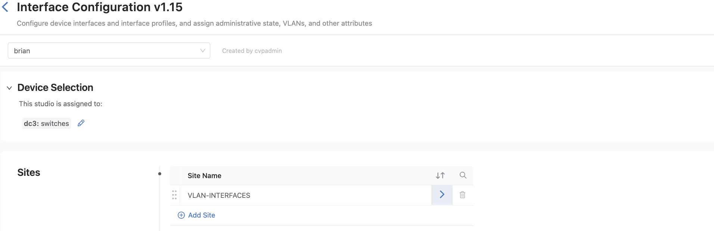

# POE, DOT1x, ACL, QOS, PIM, PTP, Logging, Storm Control:

All profile features are tested on all devices using the same setup as the General Profiles Test but adding in the various other profiles tested in combinations using the Interfaces Profiles construct. Some Profiles only apply to Routed ports and other only to L2 Ports.

1. POE Profiles (non port channel) 720XP – dc3-leaf2, dc3-leaf3, dc3-leaf4
2. Dot1x / Port Security Profiles (Dot1x na for port channels)
3. PIM profiles (only applicable to routed port)
4. ACL profiles L2 Port
5. ACL Profiles Routed Port
6. QOS Profiles L2 Port
   1. Policy Map
   2. QOS Profile
7. QOS Profiles Routed Port
   1. Policy Map
   2. QOS Profile
8. PTP profiles
9. Storm Control Profile
10. Logging Profile

## PROFILES TESTING ON ACCESS PORTS

## PROFILES TESTING ON ROUTED PORTS

PROFILES TESTING ON TRUNK PORTS

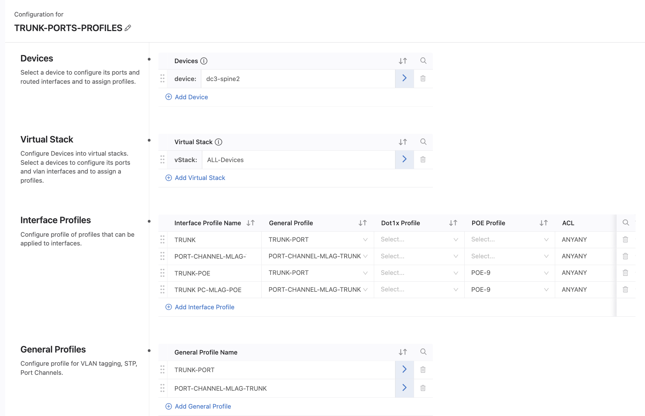

PROFILES TESTING ON PHONE PORTS

## Topology

Inputs files and Test Plan



